**STOCK MARKET CHARTING**

**Training Project**

**For**

**Middleware training**

**(Milestone-1)**

**Submitted by**

**Deepika Bomma**

**765814**

**(Programmer Analyst Trainee)**

Tabel of Content

1. Admin Login

2. Data Import

3. Manage Company

4. Manage Exchange

5. IPO Planned

6. User Login & Registration

7. User Company List

8. User Stock Charting

9. Database schema

References

1.Admin Login : The Admin can login into the portal using this screen and can get access to the admin functionalities like adding the company and updating the company details, maintain the ipo’s list, adding stocks and giving details about the stock price.

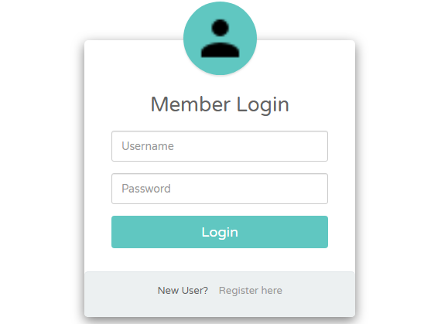

Fig: 1.1 Admin Login

2.Import Excel Data: Form this page the admin can import the data of the Stock exchange like company code ,stock exchange, price, date and time. This allow the user for further making the charts of the stocks and company data according to the period.

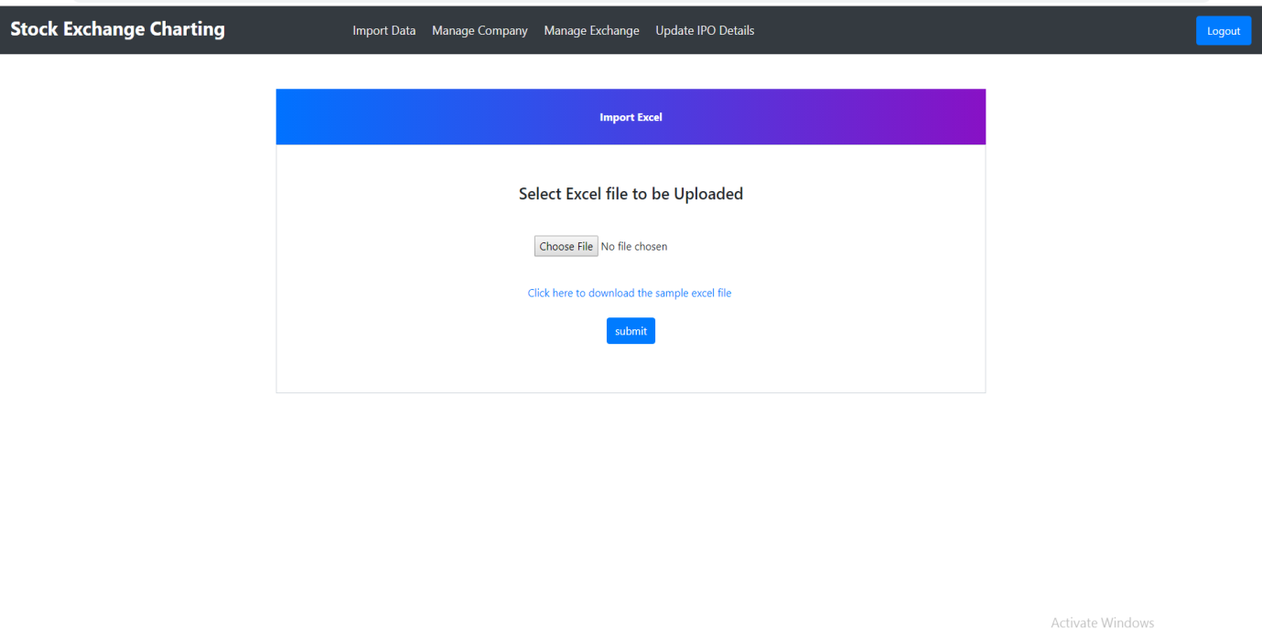

Fig: 2.1 Import Excel data

3.Manage Company :- This feature allow the admin to add the company details and the company list. The admin can view the available company and get the data about the company. The admin can also deactivate the company so that can’t be used by the user for the charting and other uses. I have also introduced the responsive feature to this so that user can get the view from any of the device.

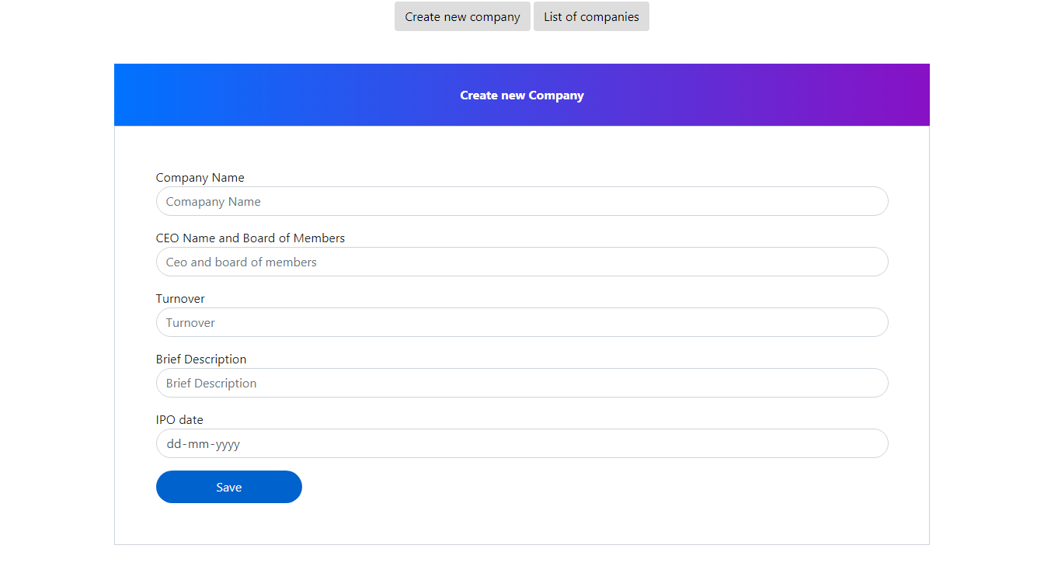

Fig: 3.1 Adding a new company

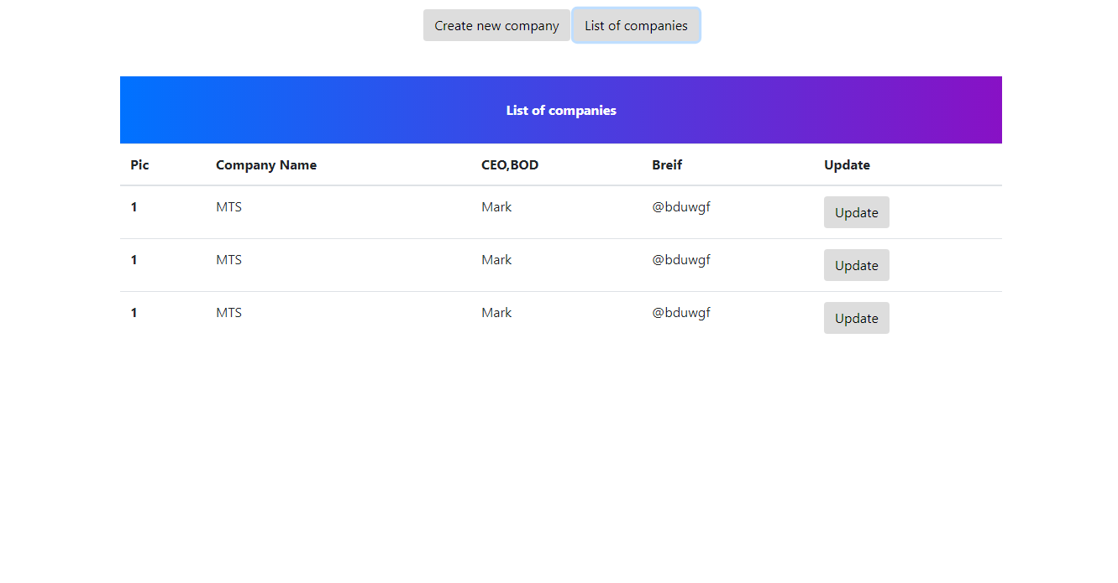

Fig: 3.2 List of Companies

4.Manage Exchange:- The Admin has to give the stock prices of the company that he added. So the admin first needs to register the stock of the company and get the value from the stock price. Then the admin can add the excel file to the company data to add the historical data.

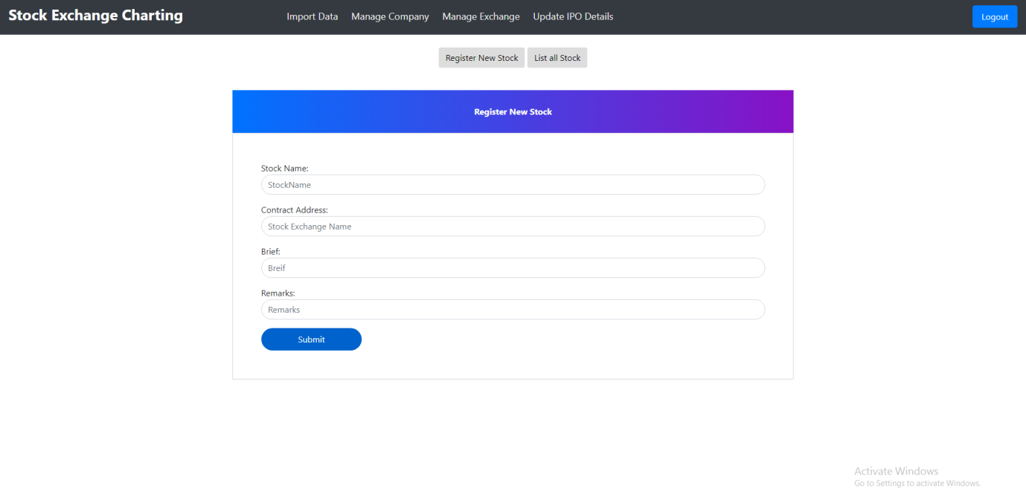

Fig: 4.1 Registering a New stock

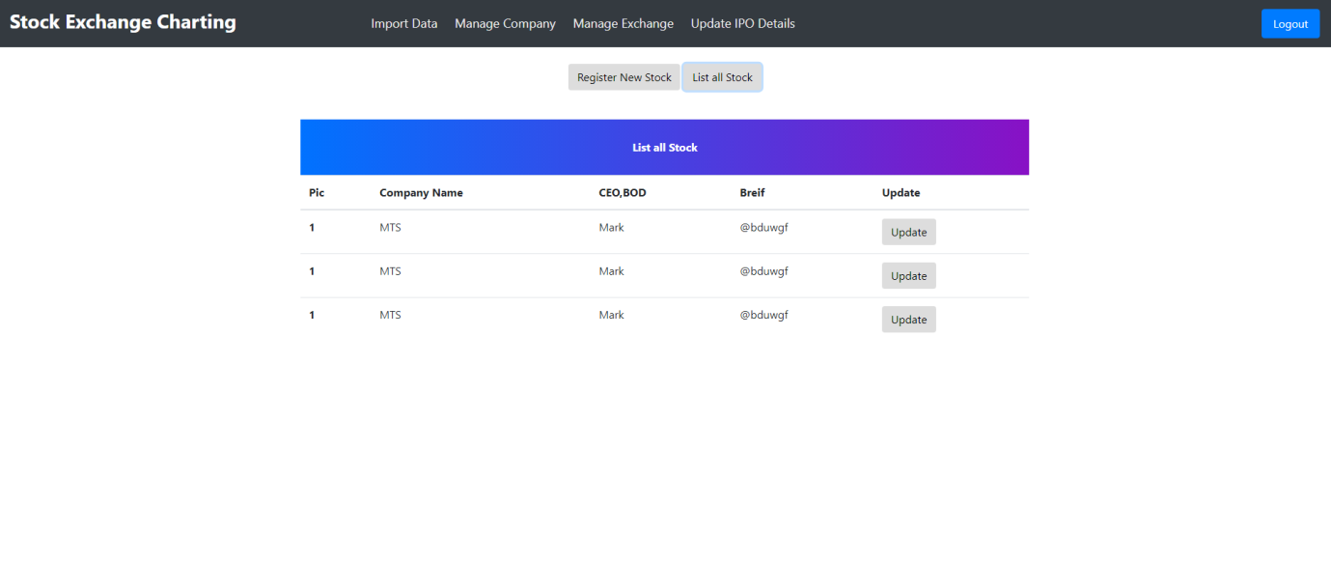

Fig: 4.2 List of all stock

5.IPO Planned :- The Admin need to add the ipo details for every registered company so that user can get the investments plan of that registered company. For every user the company maintains the ipo for every shares that the user owns.

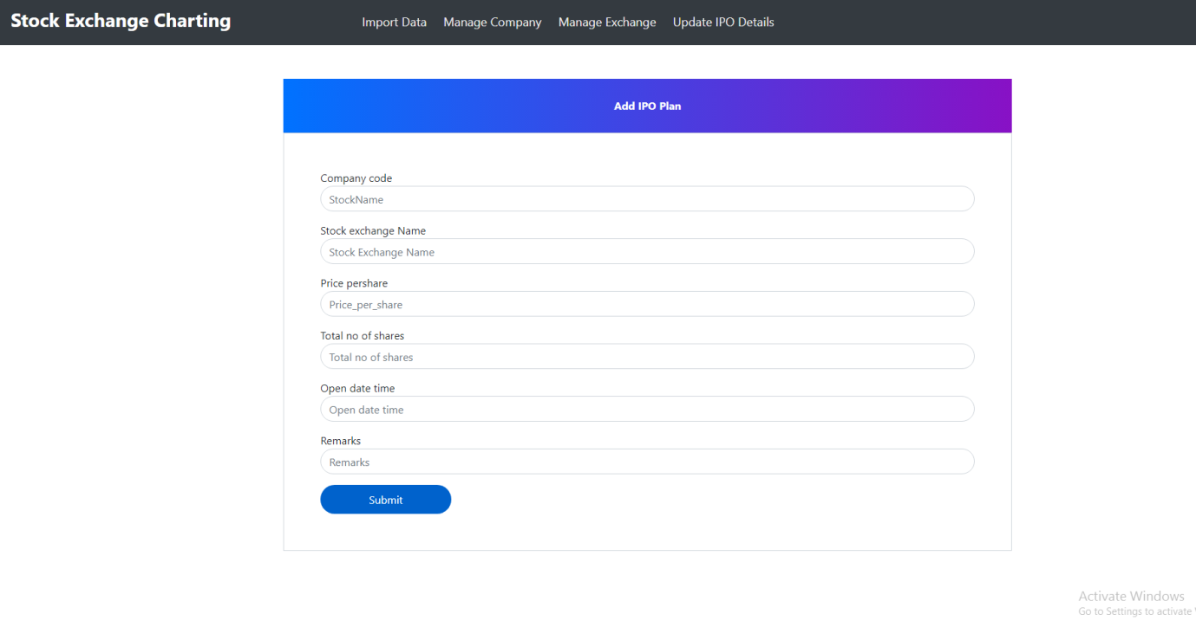

Fig: 5.1 Ipo planned

6.User Registration &Login :- The user can access the stock market charting after registration and login through the portal using this portal.



Fig: 6.1 User Login page

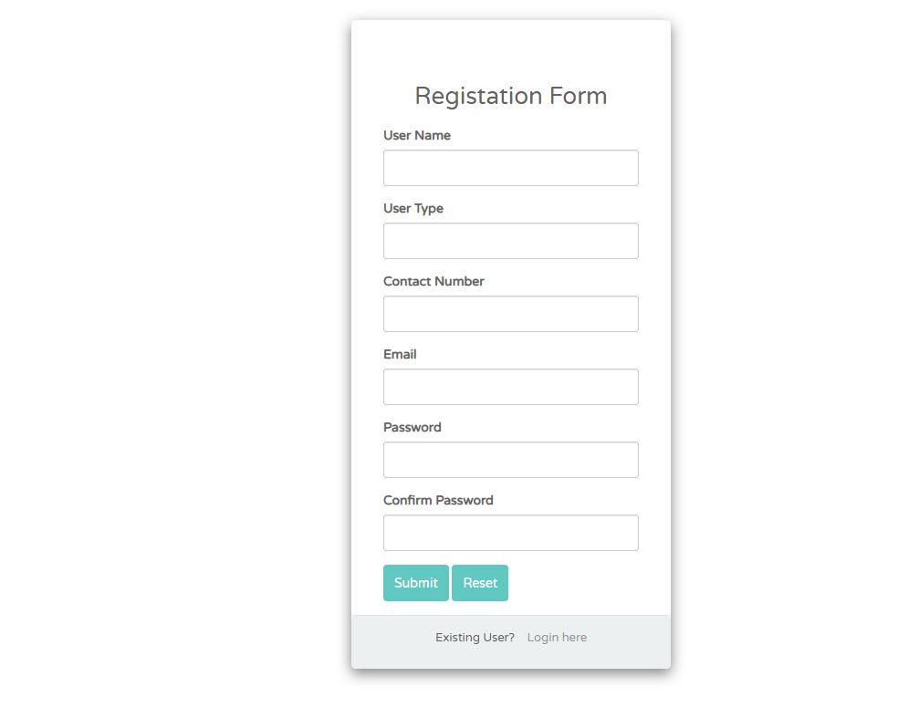

Fig: 6.2 Registration page

7.User Company List:- The user can see the data of the company and all the companies in this tab.

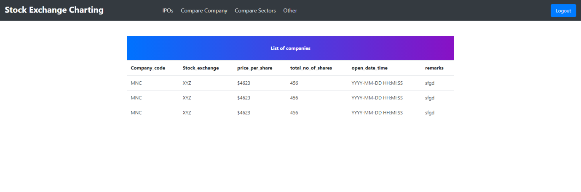

Fig: 7.1 List of companies

8.User stock charting :- In this view the user can view the charts of the company and compare between the different company charts between specific period.

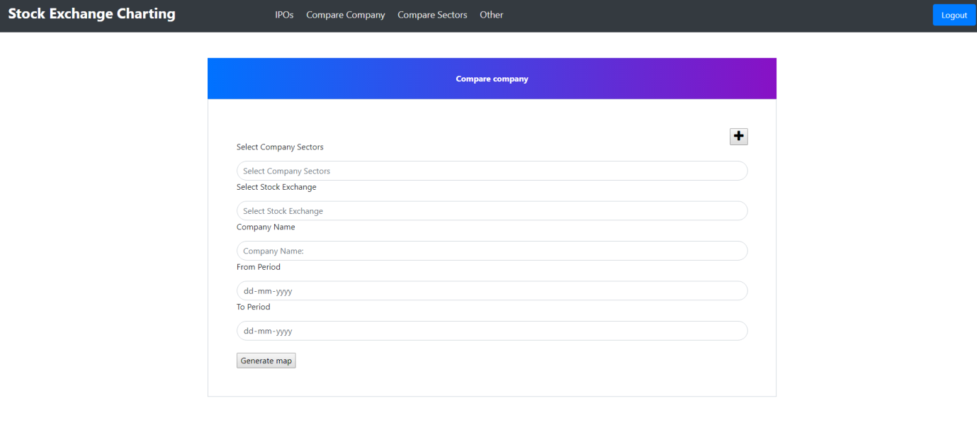

Fig: 8.1 Comparision of stocks

9.Database schema:- The stock market charting has the different entity classes which establish the different kinds of the relationship among them. The different entity classes are as follows.

1. Company.

2. Stock Price Details.

3. IPO’s Planned

4. Sector.

5. User.

6. Stock Exchange.

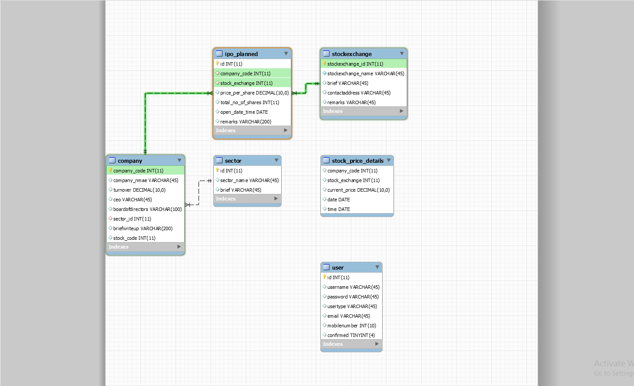

Fig: 9.1 Database schema

References:

<https://github.com/DeepikaBomma/stock_market_charting>